CV
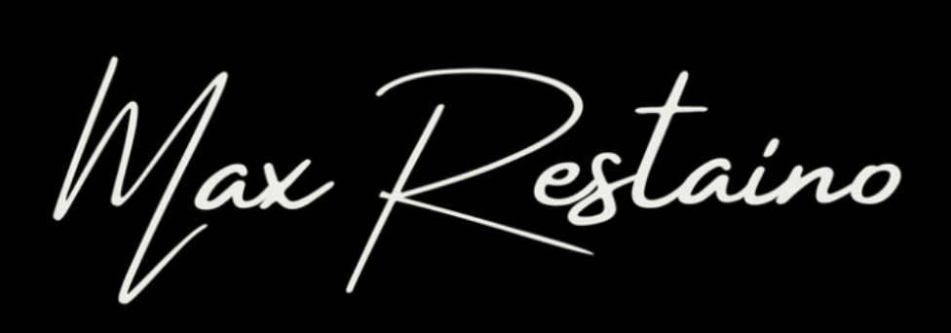
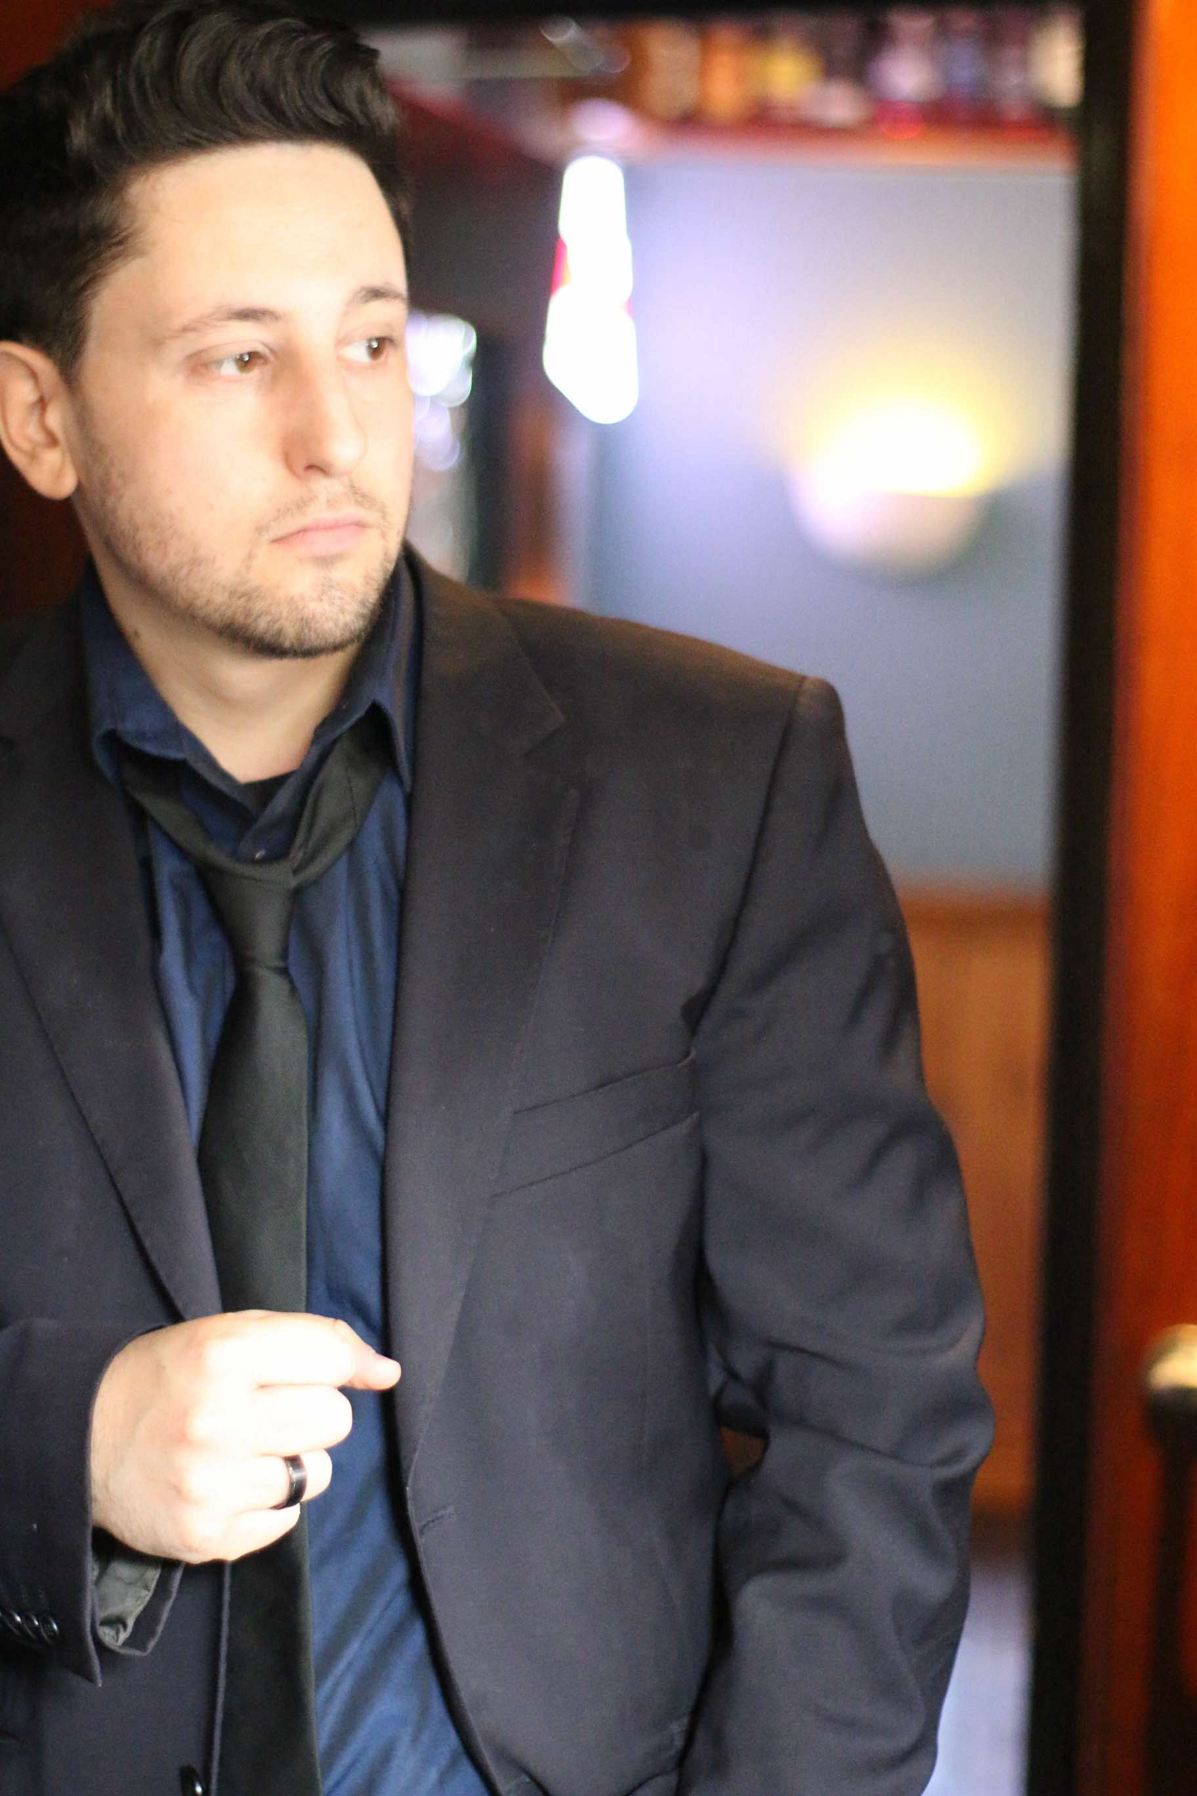

Max Restaino is an award-winning composer, singer-songwriter, multi-instrumentalist and producer with ten years' experience working in the music industry. He has performed and worked alongside some of the biggest names in the music industry, including Donny Osmond, Tears For Fears, UB40, Gary Barlow, Steps and Peter Andre.

Max obtained a scholarship to attend The University of Sheffield Music School at a very young age but quickly moved on when offered an internship at the infamous Steelworks Studio in Sheffield. Having completed a two-year internship under the expert supervision of songwriter and music producer Eliot Kennedy, Max went on to work on the following projects:

Peter Kay's Car Share - BBC One - (vocals)
Peter Kay's Phoenix Nights Live Show (Vocals)
Gary Barlow - Let Me Go (Accordion)
Donny Osmond's 50th Album Live Studio Video (Accordion)
Gregory Porter (Sax)
Olly Murs (Sax)
Mark S Jacob (LA Film Director -Glee) Documentary Series Mission Angels (Max Composed and produced the full score)
Peter Andre's UK Tour (Special Invited Guest)
Steps UK Arena Tour (Special Invited Guest)
UB40 (Special Invited Guest)
Tears For Fears (Special Invited Guest)
Bauer- Hits Radio HallamFM - (In-house music producer and performer for Big John at Breakfast & Producer James)
Performed many times on BBC radio, including BBC Radio London and BBC Introducing
Awards: PRS Song writing Award -Tin Pan Alley – SKY TV
TMA Award Nomination for Role as Billy in Nikolia Foster’s
Assassins – Crucible Theatre Sheffield.
ACTING
No Angels – Declan McBride 2004 Channel 4
Assassins – Billy - Nikolai Foster’s Assassins – Crucible Theatre Sheffield.
As well as having an extensive back Catalogue with a varied range of genres, including Jazz, Pop, Folk, World Music (Italian) Folk, Classical, Electronic / Dance music, I am always more than happy to compose, produce or perform to order any genre, work to a deadline &/or collaborate with clients to suit any project.

LINKS:-

EPK -
https://www.maxrestaino.com/epk.
(Password: epk)

CATALOG – https://www.maxrestaino.com/musiccatalog

WEBSITE -
http://www.maxrestaino.com

Contact:
Email: hello@maxrestaino.com

Tel: 0781554041

